All csv files can be merged by county FIPS/ ZIPS and Year.

DETAILED DESCRIPTIONS OF DATA FILES

==============================================

**Medical sets**

*medicaideligibility_othernondisabled.csv:* Annual rate of Medicaid Eligibility by states from 2011 to 2016 (calculated as a percent of the Federal Poverty Level (FPL))

*health_insurance_sahie.csv:* 2008 - 2020 Small Area Health Insurance Estimates (SAHIE) using the American Community Survey (ACS)

SAHIE are model-based estimates of health insurance coverage for demographic groups within counties and states. We publish state estimates by sex (female, male, both), race/ethnicity (all races, non-Hispanic White, non-Hispanic Black, Hispanic), age (0-18, under 65, 18-64, 21-64, 40-64, 50-64), and income. We publish county estimates by the same sex, age and income groups, but not by race. Income groups are defined by the income-to-poverty ratio (IPR) – the ratio of family income to the appropriate federal poverty level. We produce estimates for all incomes, and for the IPR groups: 0-138%, 0-200%, 0-250%, 0-400%, and, beginning in 2012, 138-400% IPR.

2005 - 2007 Small Area Health Insurance Estimates (SAHIE) using Current Population Survey (CPS) Data

Source:

1. (data): <https://www.census.gov/data/datasets/time-series/demo/sahie/estimates-acs.html>
2. (model): <https://www.census.gov/programs-surveys/sahie/technical-documentation/methodology/demographic-income-model.html>

* *Note: The methodology was updated in 2013. 2005-2007 used different surveys for input data.*

*opioid_overdose_mortality.csv:* lower bound and upper bound of the opioid-related death rate by county from 1999-2015

Source: <https://data.cdc.gov/NCHS/NCHS-Drug-Poisoning-Mortality-by-County-United-Sta/pbkm-d27e>

**Economic sets**

*unemployment_county_2000_2020.csv*: Annual averages unemployment rates by county from 2000-2020 (Source: <https://www.bls.gov/lau/tables.htm#cntyaa>)

*unemployment_zcta5_acs.csv:* Annual averages employment and unemployment rates by Zip code from 2005-2021

2011-2021: ZIP code data from the Census API

2005-2010: County (>65k population) data from Census API then crosswalk to ZIP code

(Source: ACS Census API)

Foreclosure: paid dataset

<https://www.attomdata.com/data/foreclosure-data/>

*bankruptcy_filings_circuit.csv:* Number of bankruptcy filings by circuit of judicial courts for 12-month period ending December 31 from 2005 to 2018

(U.S. Bankruptcy Courts—Business and Nonbusiness Cases Filed, by Chapter of the Bankruptcy Code)

“CHAP. 7," shows the number of bankruptcy filings that involve liquidation of assets.

"CHAP. 11," displays the number of bankruptcy filings which are primarily used for reorganization of businesses.

"CHAP. 12," represents the number of bankruptcy filings which are specifically designed for family farmers and fishermen.

"CHAP. 13," indicates the number of bankruptcy filings which involve a repayment plan for individuals with regular income.

(Source: <https://www.uscourts.gov/statistics-reports/caseload-statistics-data-tables?tn=F-2&pn=32&t=All&m%5Bvalue%5D%5Bmonth%5D=12&y%5Bvalue%5D%5Byear%5D=>)

*poverty_saipe.csv:* poverty estimates, median household income, estimates of school-age children in poverty by year and by county from 2005-2020 by SAIPE, Census Bureau

Small Area Income and Poverty Estimates (SAIPE) Program provide single-year estimates of income and poverty for all U.S. states and counties as well as estimates of school-age children in poverty for all 13,000+ school districts from these **inputs: state IRS data, state SNAP benefits data, county SNAP benefits data, and state/county poverty universe data.**

Source:

1. Data: <https://www2.census.gov/programs-surveys/saipe/datasets/>
2. Model: <https://www.census.gov/programs-surveys/saipe/technical-documentation/methodology.html>

*poverty_zcta5_acs.csv*: Percentage of households with income below poverty level, median household income by ZIP code from 2005-2021 from ACS

2011-2021: ZIP code data from the Census API

2005-2010: County (>65k population) data from Census API then crosswalk to ZIP code

Source: ACS Census API

*owned_rent_zcta5_acs.csv*: Percentage of owned and rent households by ZIP code from 2005-2021

2011-2021: ZIP code data from the Census API

2005-2010: County (>65k population) data from Census API then crosswalk to ZIP code

Source: <https://data.census.gov/table?tid=ACSDP1Y2021.DP04>

*owned_rent_zcta5_dc.csv*: Percentage of owned and rent households by ZIP code in 2000, 2010 from DC

Source: DC Census API

*The Census Bureau will not release its standard 2020 ACS 1-year estimates because of the impact of the COVID-19 pandemic on data collection.*

**Population Set**

*natural_disaster.csv*: natural disaster occurrence by county by month from 2000-2023: data published by Federal Emergency Management Agency (FEMA)

<https://www.fema.gov/openfema-data-page/disaster-declarations-summaries-v2>

*pop_density_zcta5_dc.csv*: person per square miles of land area by ZIP in 2010 calculated using the population and land area (square miles)

(Source: <https://tigerweb.geo.census.gov/tigerwebmain/TIGERweb2020_nation_based_files.html> *The land area on this website is in square meters*)

*race_demographics_zcta5_dc.csv:* Percentage of each race by ZIP code in 2000 and 2010 by the Decennial Census (White, Black or African American, American Indian and Alaska Native, Asian, Hispanic or Latino)

Source: <https://data.census.gov/table?tid=DECENNIALPL2020.P1>

*race_demographics_acs.csv*: Percentage of each race by ZIP code from 2005-2021 from ACS (White, Black or African American, American Indian and Alaska Native, Asian, Hispanic or Latino)

2011-2021: ZIP code data from the Census API

2005-2010: County (>65k population) data from Census API then crosswalk to ZIP code

Source: <https://data.census.gov/table?tid=ACSDP1Y2021.DP05>

spousal abuse data

<https://www.icpsr.umich.edu/web/NACJD/studies/34305/datadocumentation#>

<https://catalog.data.gov/dataset/national-intimate-partner-and-sexual-violence-survey-nisvs-series-7e78b>

Has special restricted access to the raw data

NIPSV 2010, 2011, 2012, 2015

NCVS 2000-2015: <https://www.icpsr.umich.edu/web/ICPSR/studies/38321>

<https://www.icpsr.umich.edu/web/ICPSR/studies/22921/datadocumentation>

By county from 2000-2020

*elections.csv*: percentage of political votes by county

Progress Check

|  | Index | Raw Data | Collating | Frequency | Time Range |
| --- | --- | --- | --- | --- | --- |
| Medical | Medicaid Eligibility | Completed | Completed | Annual by state | 2011-2016 |
| Health insurances SAHIE | Completed | Completed | Annual by county | 2005-2020 |
| opioid deaths | Completed | Completed | Annual by county | 1999-2015 |
| Economic | unemployment | Completed | Completed | Annual averages by county | 2000-2020 |
| unemployment | Completed | Completed | ZCTA5 | 2011-2021  From ACS 5-year estimate  2005-2010  From ACS 1-year estimate (county to ZIP code) |
| foreclosure | Not Started | Not Started |  |  |
| Bankruptcy filings | Completed | Completed | Annual court cases by circuits | 2005-2020 |
| Percentage of Household living under the poverty threshold,: median household income | Completed | Completed | ZCTA5 | 2011-2021  From ACS 5-year estimate  2005-2010  From ACS 1-year estimate (county to ZIP code) |
| SAIPE (poverty estimates all ages, median household income) | Completed | Completed | By county | 2005-2020 |
| rent/owned | Completed | Completed | ZCTA5 | 2000,2010  From DC |
| rent/owned | Completed | Completed | ZCTA5 | 2011-2020  From ACS 5-year estimate  2005-2010  From ACS 1-year estimate (county to ZIP code) |
| Population | natural disaster occurrence | Completed | Completed | By county | 2000-2023 |
| Proportion population black | Completed | Completed | ZCTA5 | 2011-2021  From ACS 5-year estimate  2005-2010  From ACS 1-year estimate (county to ZIP code) |
| Proportion population black | Completed | Completed | ZCTA5 | 2000,2010  From DC |
| density | Completed | Completed | ZCTA5 | 2010  From DC |
| spousal abuse data | Not Started | Not Started | By state | 2010-2020 |
| political leaning | Completed | Completed | Election voting |  |

**Additional Information:**

1. Alternative sets of data for health insurance coverage but by states:

health_insurance_coverage.csv: Health Insurance Coverage: Estimates from the National Health Interview Survey 2005-2021 by states

<https://www.cdc.gov/nchs/nhis/nhis_2018_data_release.htm>

<https://www.cdc.gov/nchs/data/nhis/earlyrelease/insur200606.pdf>

(calculated from NHIS)

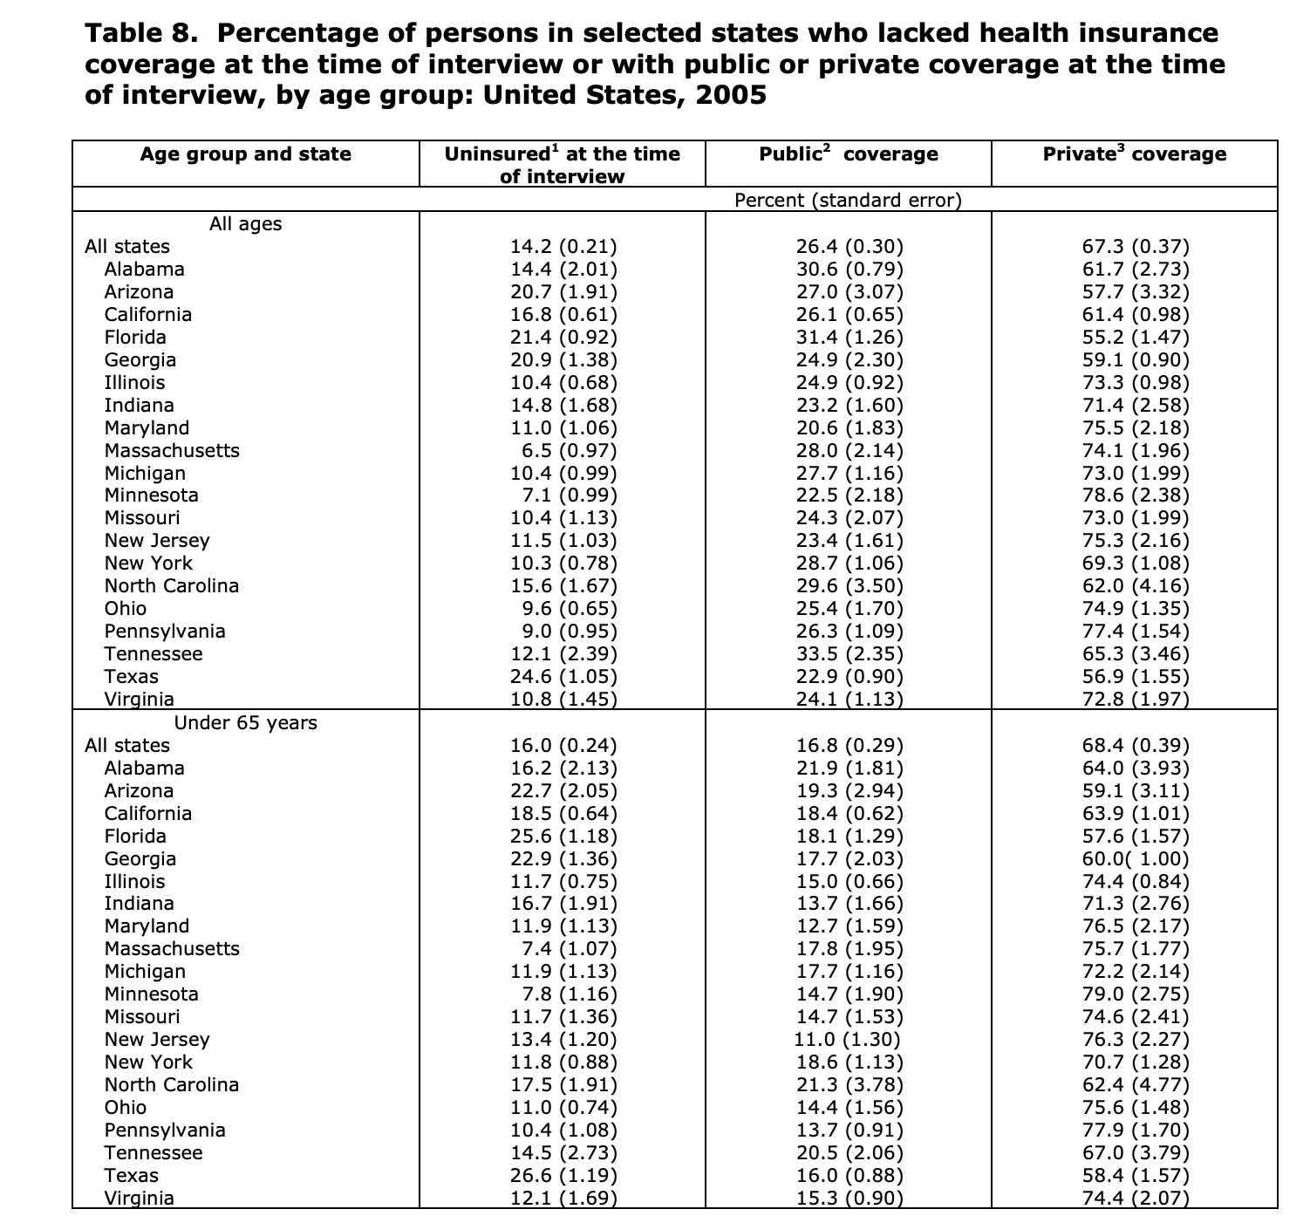

healthcare access/ coverage: BRFSS Prevalence And Trends Data: Health Care Access/Coverage for 1995-2010

Annual percentage by states

Source: <https://data.cdc.gov/Health-Statistics/BRFSS-Prevalence-And-Trends-Data-Health-Care-Acces/t984-9cdv>